**DDL Assignment 2**

**Library System**

**Use the following Schema to perform the given set of assignment. Tables-**

**Member – It contains information about the members**

|  |  |  |
| --- | --- | --- |
| **Column Name** | **Data Type** | **Description** |
| Member_Id | Integer | Unique Member ID |
| Member_Name | Varchar(30) | Name of the Library member |
| Member_address | Varchar(50) | Address of the member |
| Acc_Open_Date | Date | Date of membership |
| Membership_type | Varchar(20) | Type of the membership such as ‘Lifetime’,’ Annual’, ‘Half Yearly’,’ Quarterly’ |
| Fees_paid | Integer | Membership fees paid |
| Max_Books_Allowed | Integer | Total Number of books that  can be issued to the member. |
| Penalty_Amount | Decimal(7,2) | Penalty amount due |

**Books- It contains information about the books belongs to the library**

|  |  |  |
| --- | --- | --- |
| **Column Name** | **Data Type** | **Description** |
| Book_No | Integer | Book identification  number |
| Book_Name | VarChar(30) | Name of the book |
| Author_name | Varchar(30) | Author of the book |
| Cost | Decimal(7,2) | Cost of the book |
| Category | Char(10) | Category like Science ,  Fiction etc. |

**Issue – It contains the information about issue of the books**

|  |  |  |
| --- | --- | --- |
| **Column Name** | **Data Type** | **Description** |
| Lib_Issue_Id | Integer | Library Book Issue No |
| Book_No | Integer | Number of the book  issued |
| Member_Id | Integer | Member that issued the  book |
| Issue_Date | Date | Date of Issue |
| Return_date | Date | Return date |

**Task / Problems**:

1. Create the table Member, Books and Issue without any constraints as mentioned in the schema description above.

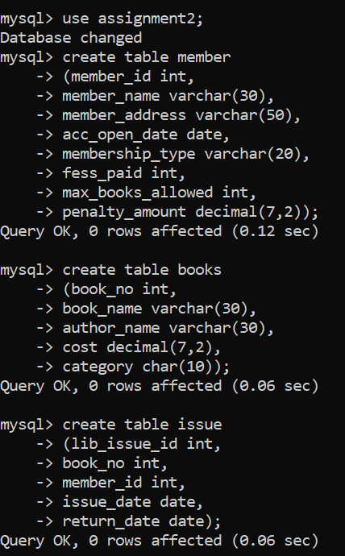

1. View the structure of the tables.

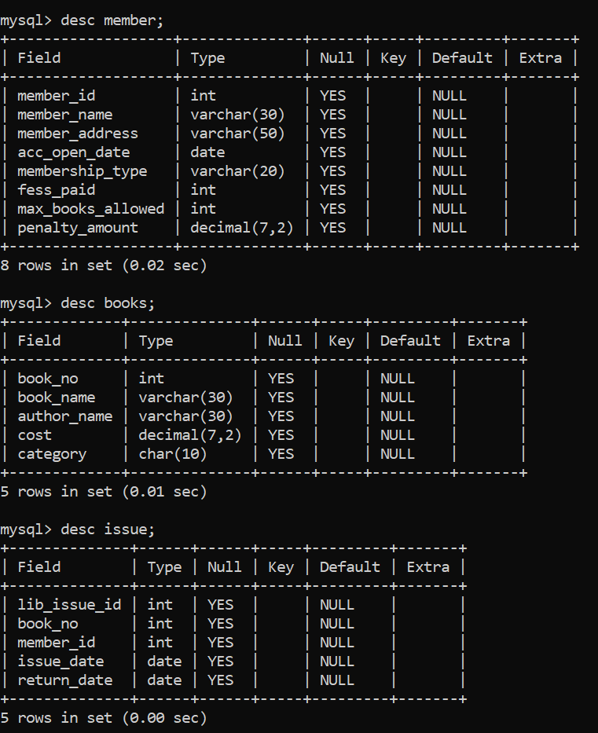

1. Drop the Member table

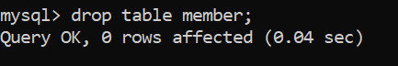

1. Create the table Member again as per the schema description with the following constraints.
   1. Member_Id – Primary Key
   2. Membership_type - ‘Lifetime’,’ Annual’, ‘Half Yearly’,’ Quarterly’

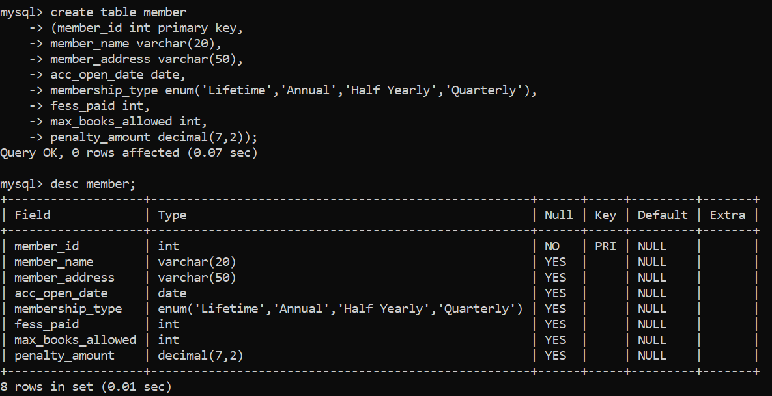

1. Modify the table Member increase the width of the member name to 30 characters.

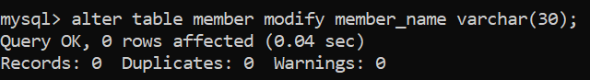

1. Add a column named as Reference of Char(30) to Issue table.

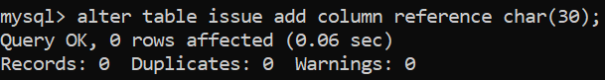

1. Delete/Drop the column Reference from Issue.

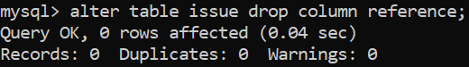

1. Rename the table Issue to Lib_Issue.

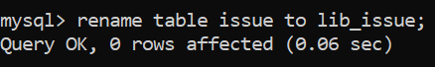

1. Insert following data in table Member

|  |  |  |  |  |  |  |  |
| --- | --- | --- | --- | --- | --- | --- | --- |
| **Member ID** | **Member Name** | **Member Address** | **Acc_Open_Date** | **Membership_type** | **Fees_Paid** | **Max_Books**  **_Allowed** | **Penalty_ Amount** |
| 1 | Richa Sharma | Pune | 10-12-05 | Lifetime | 25000 | 5 | 50 |
| 2 | Garima Sen | Pune | current date | Annual | 1000 | 3 | Null |

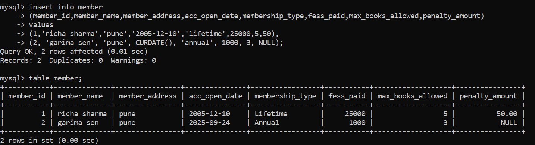

10)Insert at least 5 records with suitable data.

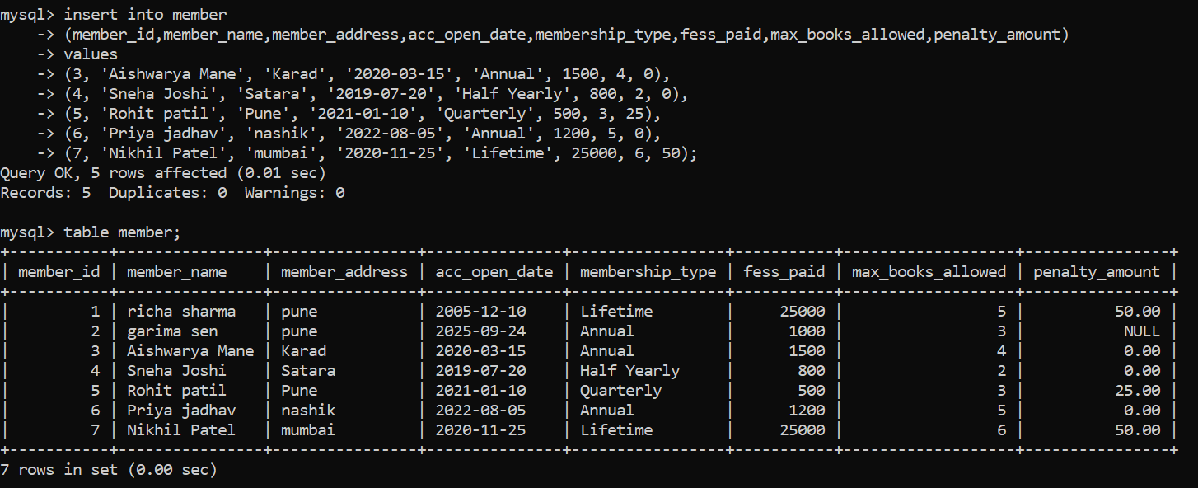

1. Modify the column **Member_name**. Decrease the width of the member name to 20 characters. (If it does not allow state the reason for that)

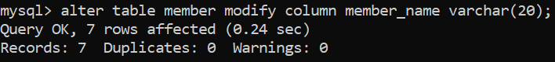

1. Try to insert a record with Max_Books_Allowed = 110, Observe the error that comes.

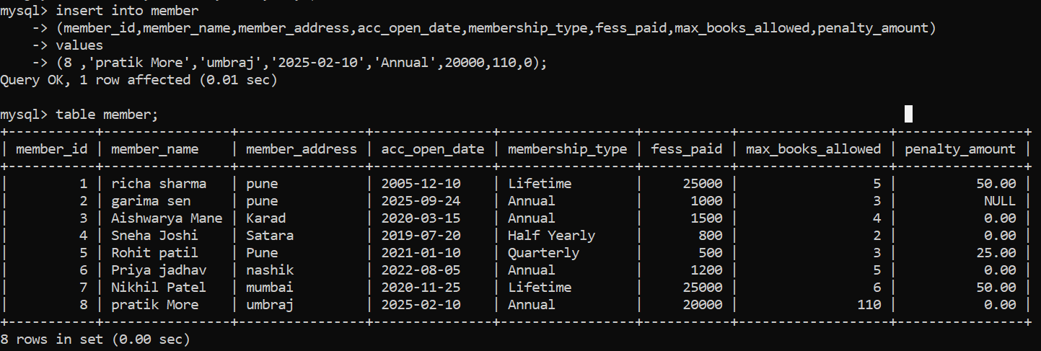

1. Generate another table named **Member101** using a Create command along with a simple SQL query on member table.

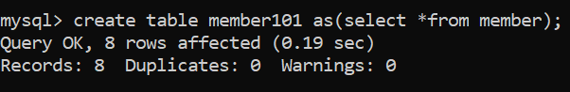

1. Add the constraints on columns max_books_allowed and penalty_amt as follows
   1. max_books_allowed < 100
   2. penalty_amt maximum 1000 Also give names to the constraints.

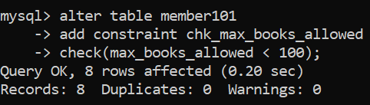

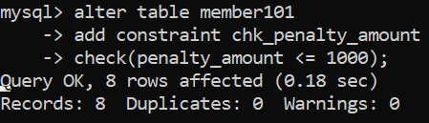

1. Drop the table books.



1. Create table Books again as per the schema description with the following constraints.
   1. Book_No – Primary Key
   2. Book_Name – Not Null
   3. Category – System, Fiction, Database, RDBMS, Others.

mysql> create table books

-> (book_no int primary key,

-> book_name varchar(30) not null,

-> author_name varchar(30),

-> cost decimal(7,2),

-> Category ENUM('System', 'Fiction', 'Database', 'RDBMS', 'Others')

-> );

Query OK, 0 rows affected (0.06 sec)

1. Insert data in Book table as follows:

|  |  |  |  |  |
| --- | --- | --- | --- | --- |
| **Book_N o** | **Book Name** | **Author** | **Cost** | **Category** |
| 101 | Let us C | Denis Ritchie | 450 | System |
| 102 | Oracle – Complete Ref | Loni | 550 | Database |
| 103 | Mastering SQL | Loni | 250 | Database |
| 104 | PL SQL-Ref | Scott Urman | 750 | Database |

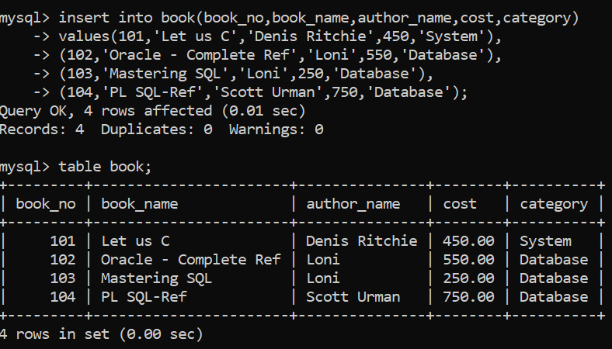

1. Insert more records in Book table.

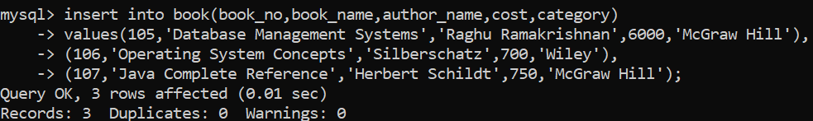

1. View the data in the tables using simple SQL query.

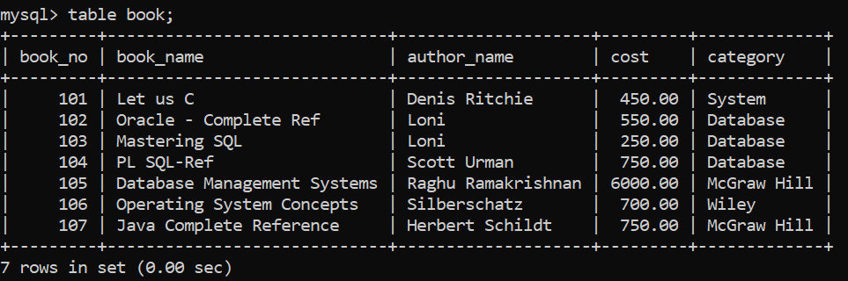

1. Insert into Book following data.

105, National Geographic, Adis Scott, 1000, Science

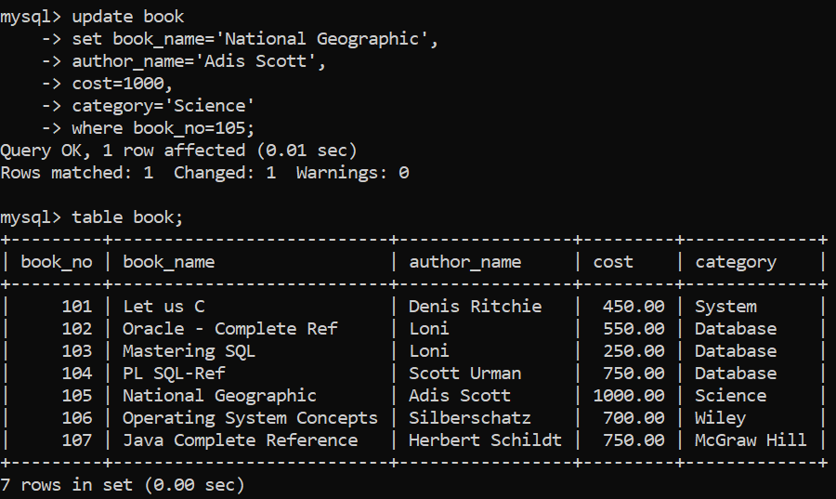

1. Rename the table Lib_Issue to Issue.

mysql> alter table lib_issue

-> rename to issue;

Query OK, 0 rows affected (0.04 sec)

1. Drop table Issue.

mysql> drop table issue;

Query OK, 0 rows affected (0.03 sec)

1. As per the given structure Create table Issue again with following constraints.

* Lib_Issue_Id-Primary key
* Book_No- foreign key
* Member_id - foreign key
* Issue_date
* Return_date

mysql> create table issue

-> (lib_issue_id int primary key,

-> book_no int,

-> member_id int,

-> issue_date date,

-> return_date date,

-> constraint fk_book foreign key(book_no)references book(book_no),

-> constraint fk_member foreign key(member_id)references member101(member_id));

Query OK, 0 rows affected (0.10 sec)

1. Insert following data into Issue table.

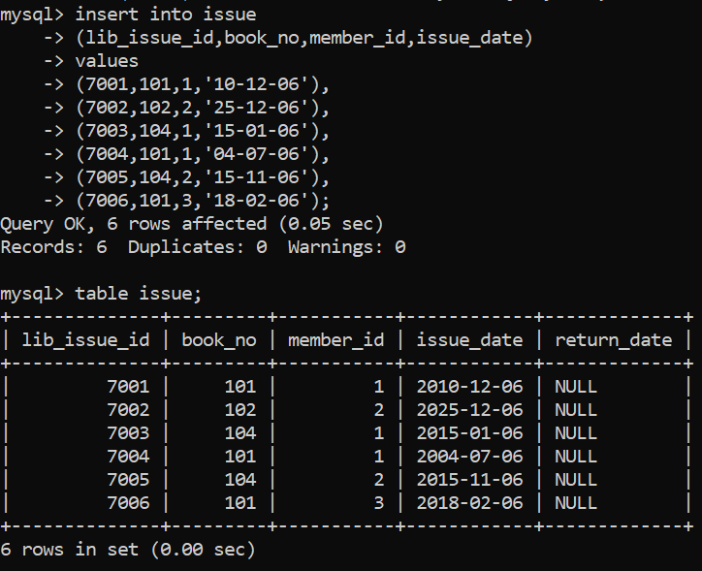

|  |  |  |  |
| --- | --- | --- | --- |
| **Lib_Issu e_Id** | **Book No** | **Member ID** | **Issue Date** |
| 7001 | 101 | 1 | 10-Dec-06 |
| 7002 | 102 | 2 | 25-Dec-06 |
| 7003 | 104 | 1 | 15-Jan-06 |
| 7004 | 101 | 1 | 04-Jul-06 |
| 7005 | 104 | 2 | 15-Nov-06 |
| 7006 | 101 | 3 | 18-Feb-06 |

1. Remove the constraints on Issue table

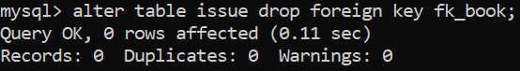

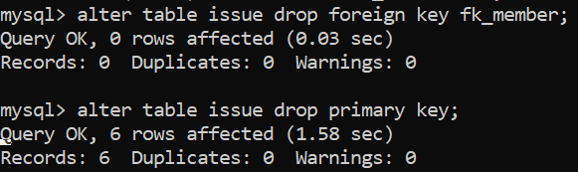

1. Insert a record in Issue table. The member_id should not exist in member table.

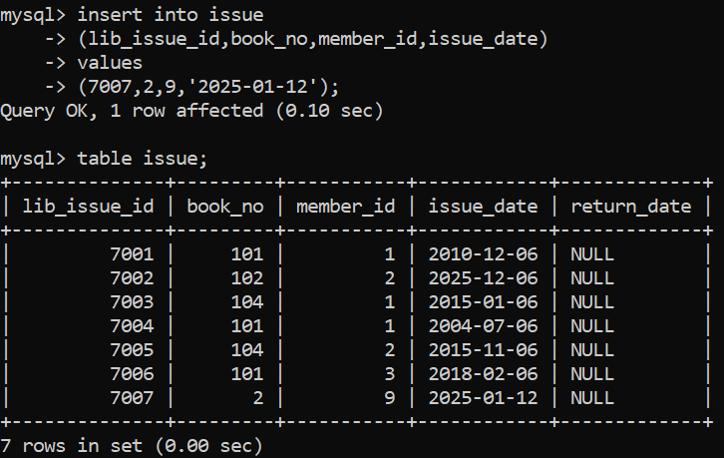

1. Now enable the constraints of Issue table. Observe the error

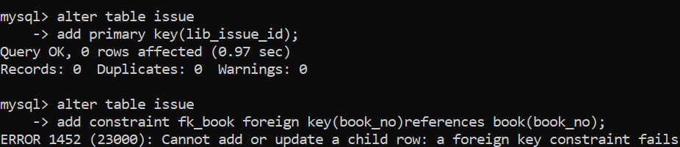

1. Delete the record inserted at Q-27) and enable the constraints.

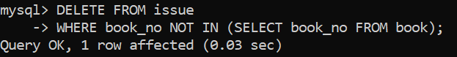

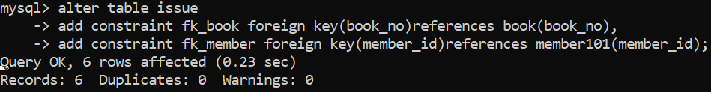

1. Try to delete the record of member id 1 from member table and observe the error .

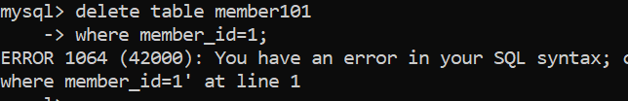

1. View the data and structure of all the three tables Member, Issue, Book.

mysql> table member101;

mysql> table issue;

mysql> table book;

mysql> desc member101;

mysql> desc issue;

mysql> desc book;

1. Modify the Return_Date of 7004,7005 to 15 days after the Issue_date.

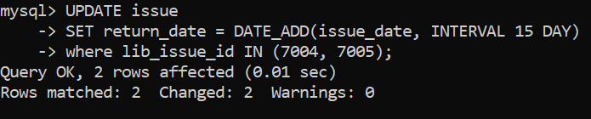

1. Remove all the records from Issue table where member_ID is 1 and Issue date in before 10-Dec-06.

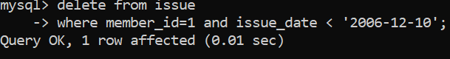

1. Remove all the records from Book table with category other than RDBMS and Database.

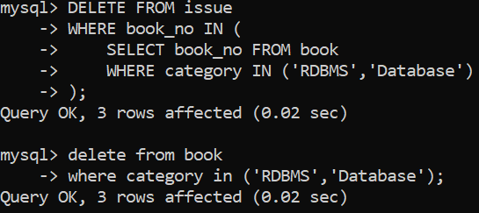

1. Remove the table Member.

mysql> DROP TABLE member101;

Query OK, 0 rows affected (0.06 sec)

1. Remove the table Book.